Assignment 28.
- Retrive data from purchase order header table and try to access by field symbol?
- Field symbol directly points to table row
- Improves performance.
- 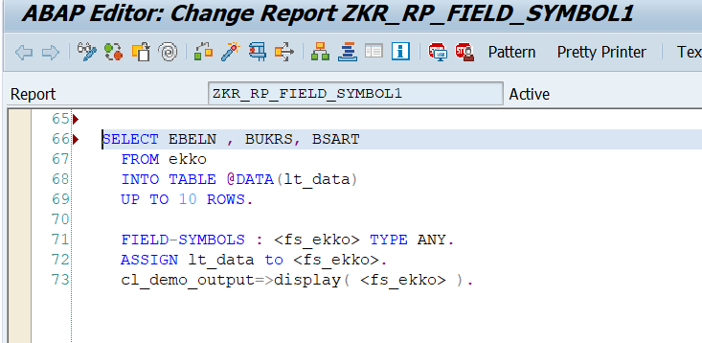
- Output:
- 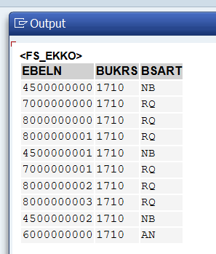
- Modify internal table field without FS and with FS?
- Without field symbol, LOOP AT uses INTO which creates a copy. Any changes need MODIFY statement to update original table. With field symbol, LOOP AT uses ASSIGNING which points directly to original — changes reflect immediately without MODIFY. Field symbol approach is faster and needs less code.
- Modify Without Field Symbol.

- 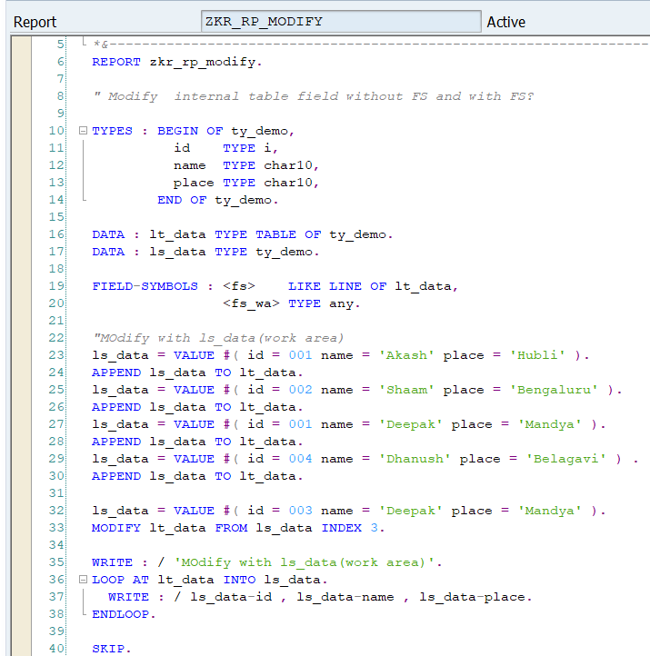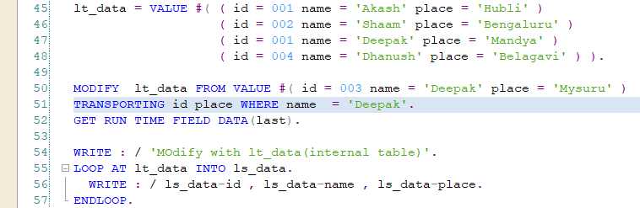
- Output:
- 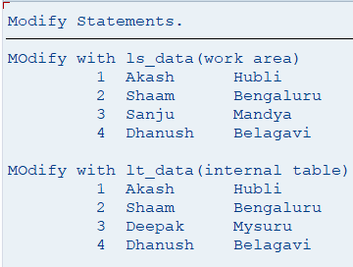 Mandya into Mysuru.
- Modify with Field Symbol:
- 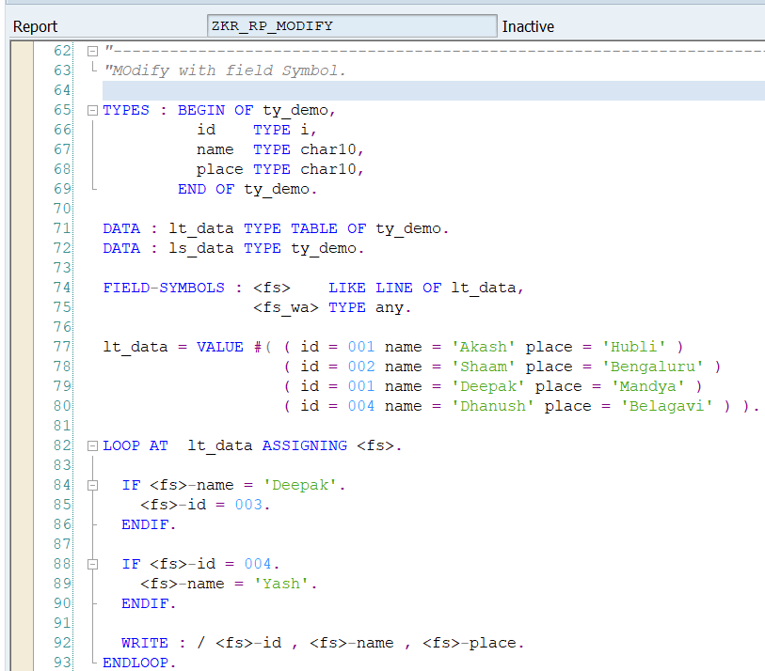
- Output:
- 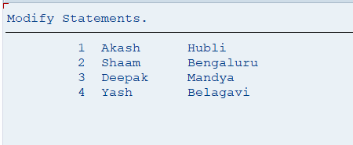
- Perform any operation and calculate time required for both ( Without FS and with FS)?
- With Field Symbol :-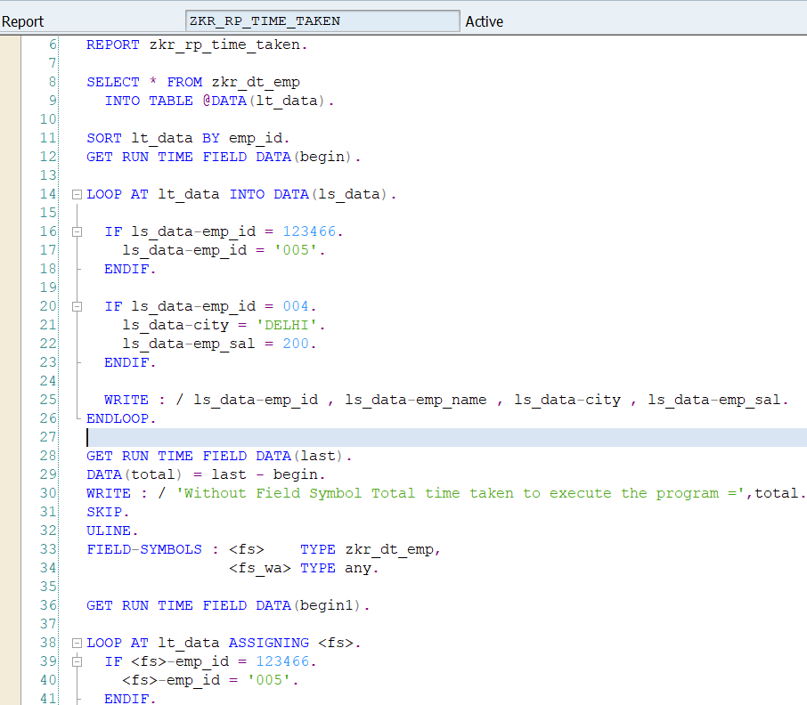
- With Field Symbol:-
- 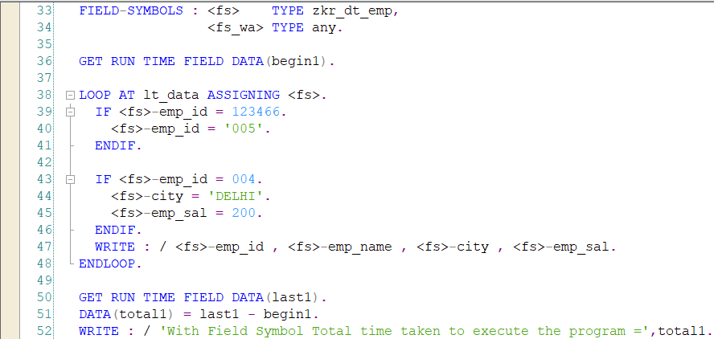
- Output:
- 